**Raspberry Pi/**

**Visual Studio 2015**

**Setup Guide**

**Table Of Contents**

1. **Introduction…………………………………………... 2**
   1. **Prerequisites……………………………………………….... 2**
   2. **Important Notes……………………………………………... 2**
2. **Installation Procedure………………………………. 3 - 6**
   1. **Visual Studio Enterprise 2015 With Update 3…………... 3**
   2. **Developer Mode……………………………………………… 4**
   3. **Windows IoT CoreTemplates.vsix………………………… 5**
   4. **Create Background Application (IoT).............................. 6**
3. **Errors And Bugfixes…………………………………. 7 - 9**
   1. **Creation Popup Error………………………………………… 7**
   2. **Creation Popup Error Solution…………………………….. 8**
   3. **Fix For VS 2016 Update 3…………………………………… 9**
4. **References……………………..……………………... 10**
   * **Resources Zip Folder**
   * **VS 2015 w/ Updates Download**
   * **Instructions to download Update 3 patch**

**1. Introduction**

Raspberry Pi is the main component for creating any IoT projects. In this instance, the project uses Visual Studio Enterprise 2015 Update 3.

I will be explaining step-by-step how to set up the Visual Studio to enable the creation of a Background Application (IoT) to create an IoT Raspberry Pi project.

**1.1 Prerequisites**

Before starting, we will be checking for all of the necessary components to start the setup.

Please ensure that you have the following items:

* Resource Zip Folder
  + DataCommsStarters
  + GrovePi_DLL
  + Practicals 0 - 13
  + WindowsIoTCoreTemplates.vsix
* Visual Studio Enterprise 2015 with Update 3

The “Resource Zip Folder” will contain all IoT Raspberry Pi practicals and important project components. You must request this file from your supervisor. Alternatively, you may also download from this Google Drive [link](https://drive.google.com/file/d/1UWOumnqApwvKyZ2zccUzgwkWK54xzyjw/view?fbclid=IwAR3Dt5gJwdoQX0neGErd6OVEnB-ZUHFuBhLetbJtNaaOlDiU-YoGkKacBDM), if it is still accessible.

The Visual Studio Enterprise 2015 with Update 3 can be downloaded [here](https://www.kunal-chowdhury.com/2016/06/visual-studio-2015-update-3.html). Please ensure that to also have an enterprise subscription account in order to gain access after installations.

**1.2 Important Notes**

As of writing this documentation, there are rules to follow under the current NYP school regulations. With the NYP SIT Wifi, we are unable to perform any software downloads from 9am to 6pm using the school wifi. It may change in the future.

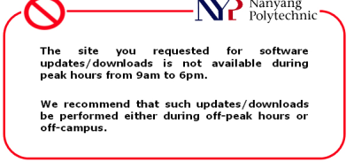

All downloads and installations will take an extremely long time. Be sure to be free and prepared to experience the long waiting times. Especially if performing these installations using the school desktop. Installation duration varies with hardware and wifi connection.

**2. Installation Procedure**

**2.1 Visual Studio Enterprise 2015 With Update 3**

First we must download Visual Studio Enterprise 2015 with Update 3. Using this [link](https://www.kunal-chowdhury.com/2016/06/visual-studio-2015-update-3.html), download “Visual Studio Enterprise 2015 with Update 3” with the tag “ISO”. Doing so, we are downloading a drive containing all Visual Studio components, the installation file, and others. Do not download the Web Installer as it will lack the VS components and give errors during installation.

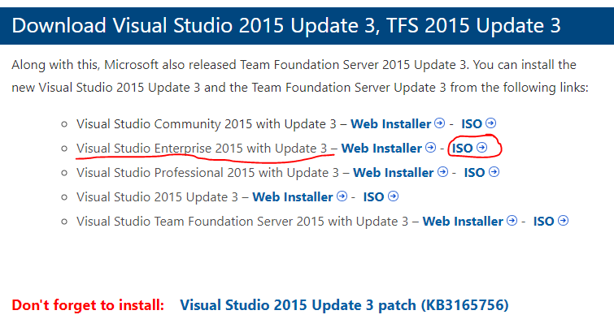

Once completed, run the installation file with .exe extension. 

Upon running the installer, it will prompt for custom settings. Do click on custom settings, then check for the following items:

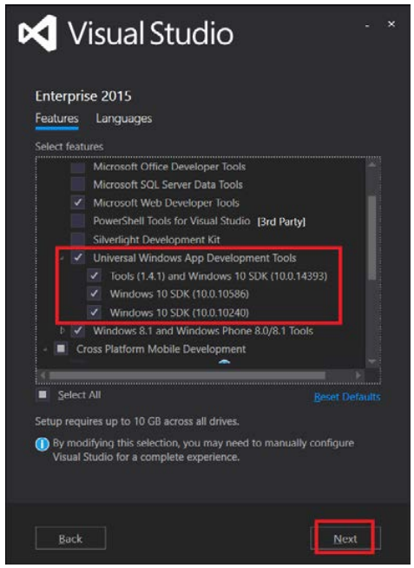

Double check carefully that the items and its versions are correct. If they are not, skip to STEP 3 for Error And Bugs fixes. Then, ensure that you have enough disk space to proceed to installation. The installation will take a while.

**2.2 Developer Mode**

On your windows, search for the “Use developer features” setting.

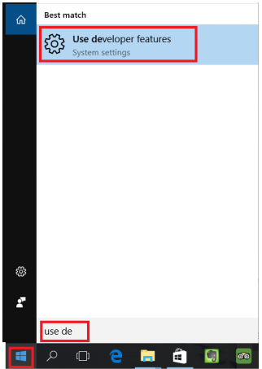

Choose the “For developers” and select “Developer mode”.

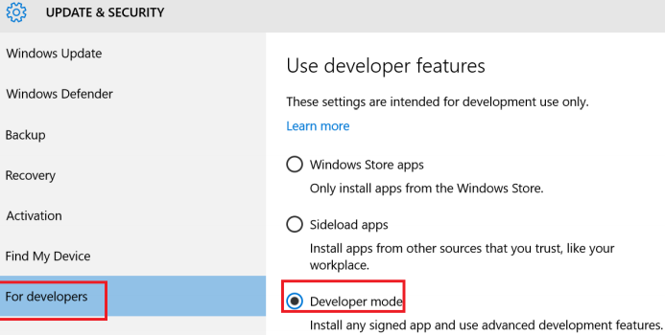

The entire process will vary depending on your windows version.

**2.3 Windows IoT CoreTemplates.vsix**

Open the previously mentioned “Resource Zip Folder” and run the “WindowsIotCoreTemplates.vsix” installer.

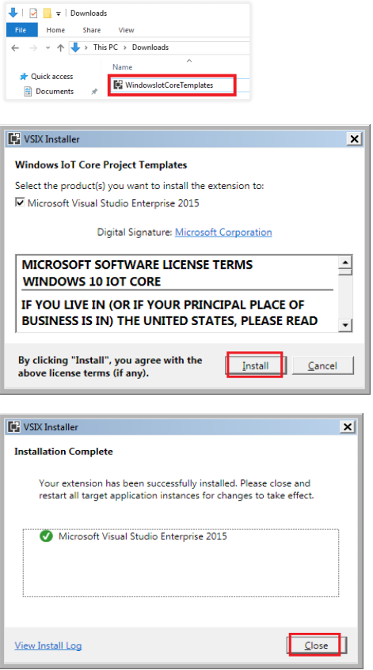

This installer will now enable the option to create a “WindowsIoT Core > Background Application (IoT)” project in Visual Studios.

**2.4 Create Background Application (IoT)**

Open Visual Studios and try to create a new project. There will be a new project type available for creation. Use that for the Raspberry IoT project.

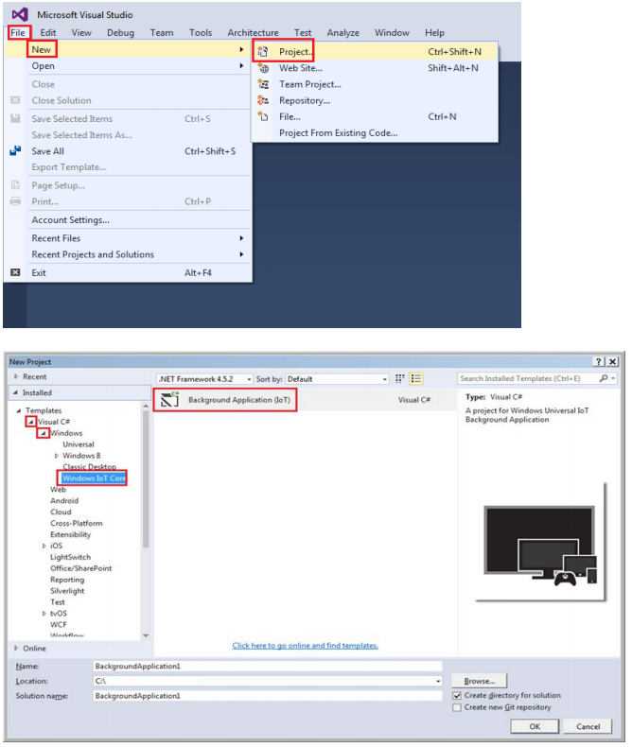

If the process is successful, you will be greeted with this final popup, just click “OK”. If not, skip to STEP 3 Errors And Bugfixes.

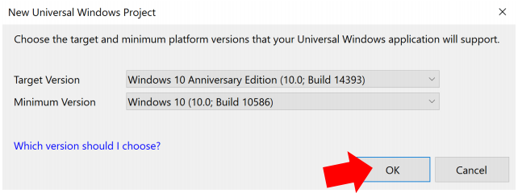

This will indicate that you have successfully downloaded Visual Studio Enterprise 2015 with Update 3, and able to create a Background Application (IoT) project. Now you may continue developing the project.

**3. Errors And Bugfixes**

This section is meant for help and solutions when facing any technical encounters following the installation procedure STEP 2.

**3.1 Creation Popup Error**

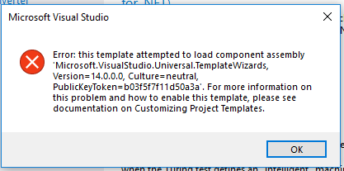

Upon creating the Background Application (IoT) project, you may face this popup error immediately after creating the project. Rarely, you may not even encounter any popups and will immediately be directed to the project. That is another form of the same error as well.

This error indicates that you lack a Visual Studio 2015 component that is required for this project type. To solve it, you must install the missing components via the installation/modify of your Visual Studio.

**3.2 Creation Popup Error Solution**

Install the missing components via the installation/modify of your Visual Studio.

To open the installation/modify of Visual Studio setup, open “Control Panel” > “Uninstall a program” > “Microsoft Visual Studio Enterprise 2015 with Updates” then right click it to select “Change”.

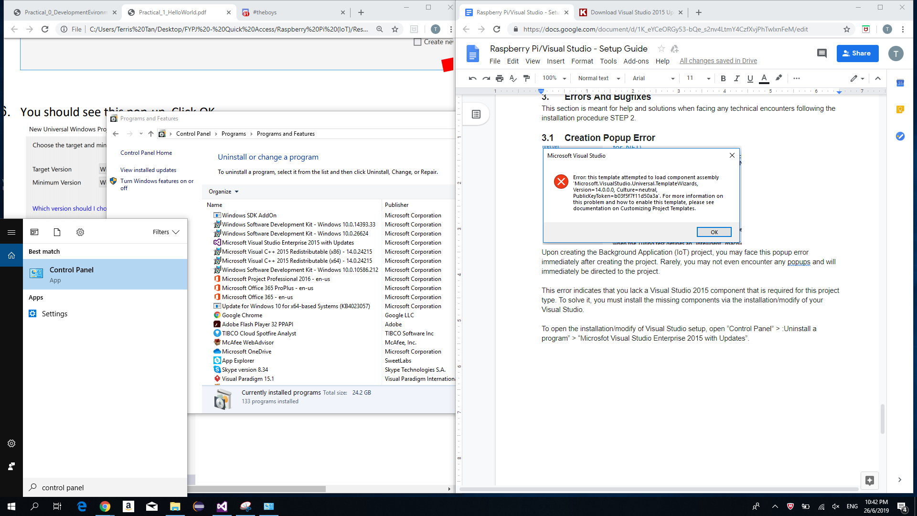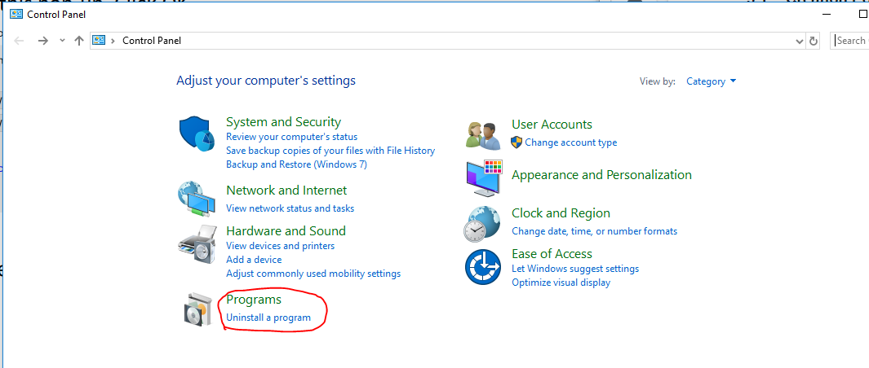

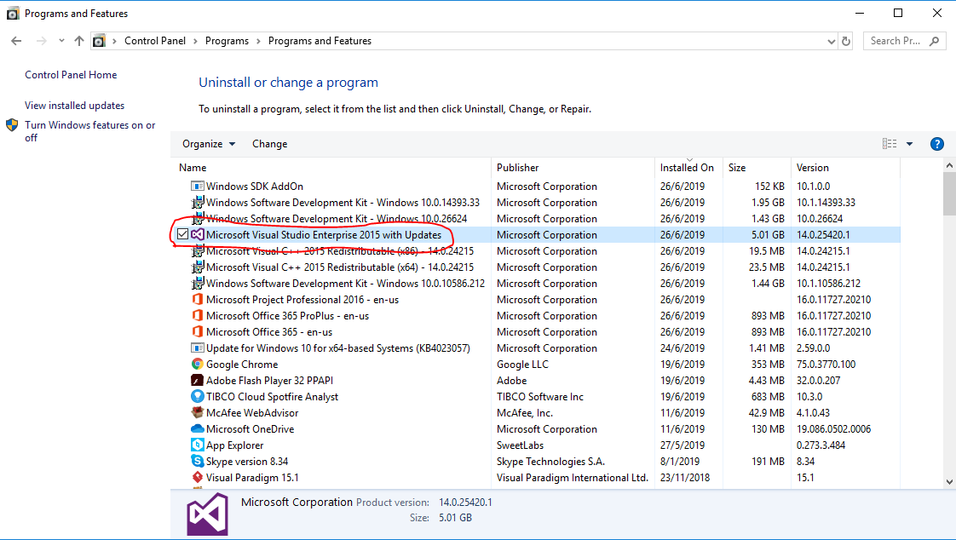

This will open up the installation/modify VS setup. When opened, select “Modify”. Then proceed to install the following in the third image. Once finished, go back to STEP 2.4.

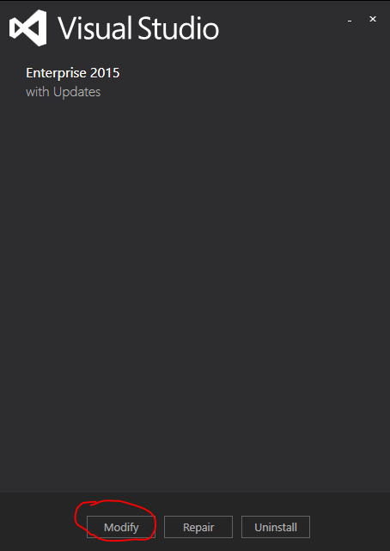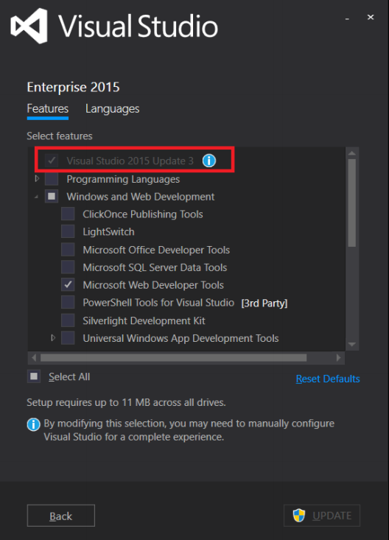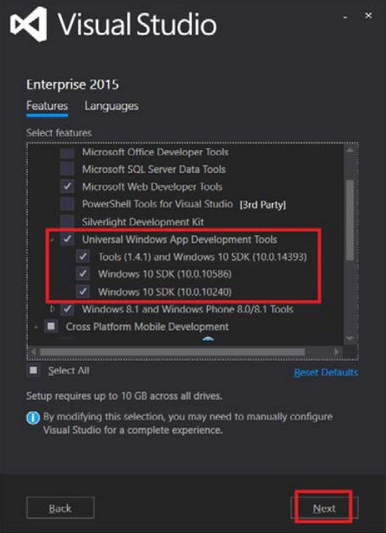

If you lack a “Visual Studio 2015 Update 3” or have different versions selections, proceed to STEP 3.3 Fix For VS 2015 Update 3.

**3.3 Fix For VS 2015 Update 3**

To ensure that you have Update 3 properly installed in your Visual Studio 2015 Update 3, I will guide you on how to install it. You may refer to this article [here](https://www.kunal-chowdhury.com/2016/07/VS14-KB3165756.html#1p9RGwZ4jSMoteYm.99) as well.

First open Visual Studio, then at the top left select “Tools > Extensions and Updates”, then continue to select “Updates > Product Updates”, and lastly install the patch file “KB3165756”. This will open an external VS setup that requires you to close VS.

Once installation for the patch file is completed, go back to STEP 3.2, and try to download the missing components. This should fix the bug.

**4. References**

Resource Zip Folder: (Ask supervisor for the file if possible) <https://drive.google.com/file/d/1UWOumnqApwvKyZ2zccUzgwkWK54xzyjw/view?fbclid=IwAR3Dt5gJwdoQX0neGErd6OVEnB-ZUHFuBhLetbJtNaaOlDiU-YoGkKacBDM>

VS 2015 w/ Updates Download

<https://www.kunal-chowdhury.com/2016/06/visual-studio-2015-update-3.html>

Instructions to download Update 3 patch:

<https://www.kunal-chowdhury.com/2016/07/VS14-KB3165756.html#1p9RGwZ4jSMoteYm.99>